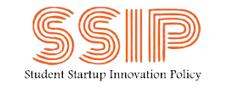
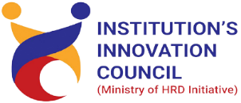
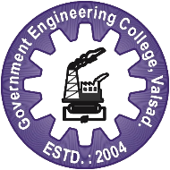

District Science Center, Dahrampur,
Mistry of Culture, Government of India

and
SSIP 2.0 and Institution’s Innovation Council GECV
Jointly organised
Make Your Own Robo: Pre-Event for Innovation Festival-2024

GOVERNMENT ENGINEERING COLLEGE, VALSAD

10th Feb, 2024 to 11th Feb, 2024

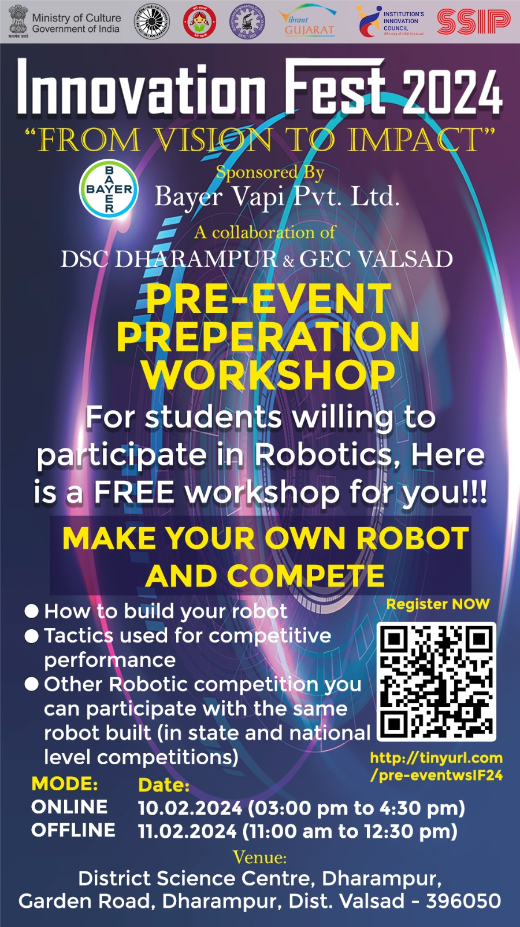

Report
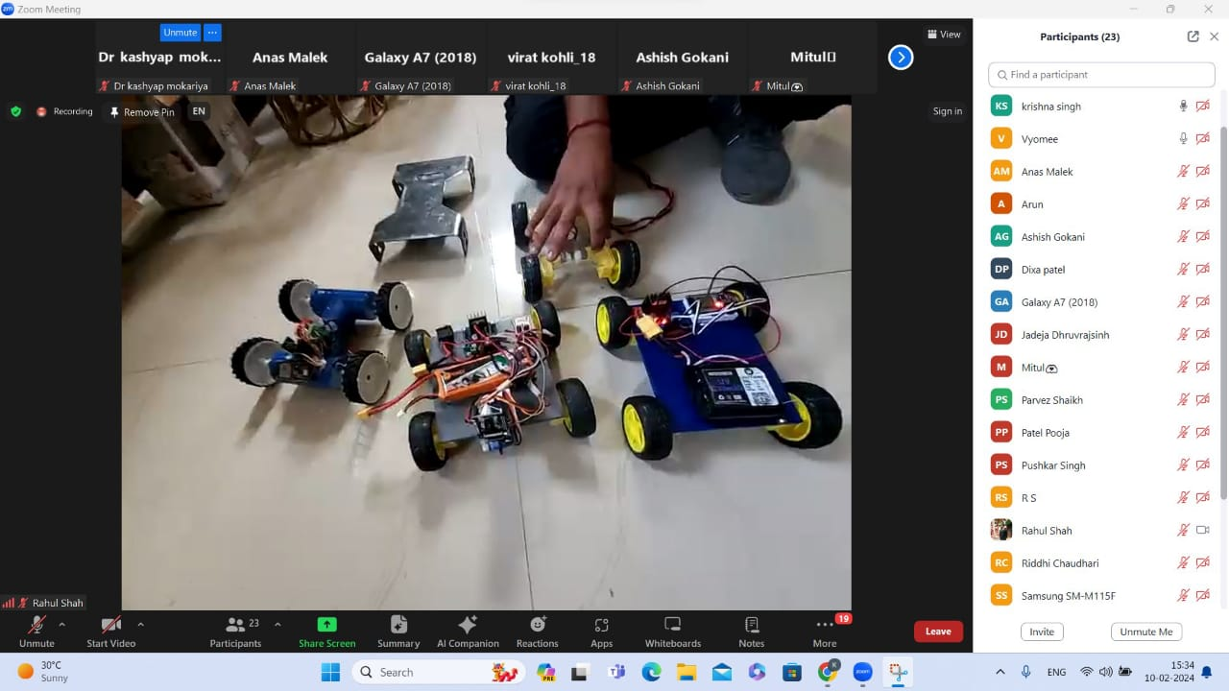

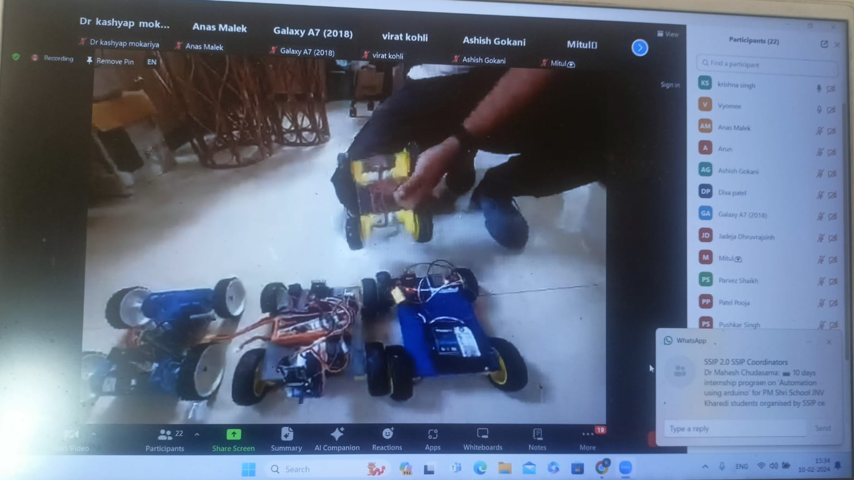

As part of the comprehensive preparations for the Innovation Festival 2024, a pre-event workshop on robot making was conducted in coordination with Government Engineering College, Valsad on February 10th and 11th, 2024. The workshop encompassed two segments - an online session on the 10th, which successfully engaged 26 students, and an offline, hands-on workshop on the 11th that involved 7 students. The online workshop served as a platform for theoretical discussions, sharing insights, and setting the foundation for the practical application of robotic concepts. Subsequently, the offline session provided a more immersive experience, allowing students to delve into the intricacies of robot making through hands-on activities. These workshops not only equipped participants with essential skills but also fostered a collaborative and innovative spirit among the students, setting an encouraging tone for their active involvement in the upcoming Innovation Festival.

Participation details
Student participants: 37 and Faculty : 05 total : 42

